**Decentralization and Local Development Programme (dldp), Albania**

**Study Tour on Waste Management in Switzerland**

**Delegation of Albanian Officials**

**(20 - 26 January 2013)**

**REPORT**

1. **Background information**

From the 20-26 January, Helvetas Swiss Intercooperation, jointly with CSD organized a study tour in Switzerland for a delegation of Albanian officials on waste management in the frame of the decentralisation and local development programme (dldp) This visit to Swiss institutions took place in the framework of the “Decentralisation and Local Development Programme” (DLDP). DLDP is part of the Swiss cooperation strategy of SDC/SECO with Albania in the domain of democratization and rule of law. It is implemented by Helvetas Swiss Intercooperation, based on a bi-lateral agreement between the government of Switzerland and Albania. The project supports the ongoing decentralization process in the country in order to consolidate the democracy and provide European standards of public services for citizens. The project supports the work of local governance units (municipalities and communes) in the regions of Shkodra and Lezha (northern Albania). The project is in its second phase of implementation.

Dldp is providing since 6 years support in the waste management sector in Northern Albania and became a recognized and important partner in this sector in Albania. Dldp support combines technical and co-financing assistance in planning and implementing waste collection and recycling systems in 12 LGUs, capacity development (inter-LGU expert groups, coaching of experts) and the development of a new and innovative model for regional solutions (regional transfer station) and cost calculation, presented at an important national conference in July 2012. In addition, dldp supported first experiences in interLGU solutions, public information campaigns and provided inputs to the national policy debate. Based on the results and needs/demands expressed by the partners, continued support in the waste management sector is planned for the phase extension (by end of 2013.

1. **The objectives of the study visit**

The objective of the study visit was twofold:

1. to introduce the main dldp partners in the Waste Management (WM) system(s) in Switzerland. The study tour should thus expose the participants to learn about the way certain issues, which they are currently faced with, are dealt at the Swiss level and allow for exchanges with Swiss practitioners active in these relevant fields
2. to plan with the main partners - through internal workshops - the detailed cooperation for 2013 in the frame of dldp (including ideas for dldp phase 3), thus gaining their commitment and ownership for the upcoming challenges to be addressed.

In line with the dldp draft yearly plan of operation of dldp, the focus of the study tour and the internal workshops was on organizational and governance aspects (including the cost and tariff systems) of the WM system, at the same time looking at different technical solutions related to waste collection and treatment (landfills, incineration). Special emphasis was also put on options and practices for intermunicipal solutions as well as the relation between local and cantonal/Central level.

The delegation was composed of officials (directors) from the Ministry of Interior, the Ministry of Environment, the Ministry of Public Works and Transport, the Ministry of Finance, the Water Regulatory Entity, the deputy Mayors of Shkodra and Lezha municipality, representatives of the private sector, national service providers and members of the dldp team[1]. The visit took place from the 20-26 January in the region of Lausanne. It was organized by a team of CSD engineers under the lead of Prof. Felix Schmidt (key expert involved in the dldp programme for the waste sector since 6 years), jointly with Helvetas Swiss Intercooperation (both from Head Office and from the dldp team). Both, CSD experts and Helvetas Swiss Intercooperation/dldp representatives accompanied the delegation during the entire study tour and organized/moderated the internal workshops (objective 2).

1. **Summary of activities[2]**

***Sunday 20 January 2013– Arrival and Introduction***

The delegation arrived at Geneva airport in the late afternoon and was transported to Lausanne in bus. During the ride, F. Schmidt (CSD) took the opportunity to welcome all the participants and to introduce them to the swiss context, from the economic, governance and social points of view. As a short reminder, he presented the waste context in Switzerland, legal specificities (incineration, different tax systems, etc) and the large diversity of existing models of organization. After a short touristic overview of the city of Lausanne, the delegation was invited for a typical dinner (fondue).

***Monday 21 January 2013 – “Exposure to the Swiss practice”***

The first day of the study tour was dedicated to the presentation of swiss waste management infrastructures, at two levels:

1. Regional and interLGU level (incineration plant Tridel in Lausanne)
2. Local level (municipality of Pully)
3. **Incineration plant “Tridel”**

Félix Schmidt (CSD) introduced the visit, as Tridel is a special place for CSD who has been piloting all the authorization process and the construction of the plant.

Stefan Nellen, President of Tridel, presented the organization of the company. Tridel Ltd is a public company, whose shares are property of 3 different perimeters, constituted by more than 150 LGUs (municipalities). ***The repartition of the shares guarantees that none perimeter could get more than 50% of shares and voices,*** in order to force the perimeters to cooperate altogether in an equitable way.

S. Nellen informed the delegation that this LGU collaboration is essential in the organization of the system. He specified ***that collaboration also takes place at the national level***. It is important that ***incineration plants are usefully situated***, in order to avoid over or under waste treatment capacity. There are 28 incineration plants in Switzerland, regulated by an ***agreement that facilitates cooperation, particularly during interruptions due to maintenance operations***.

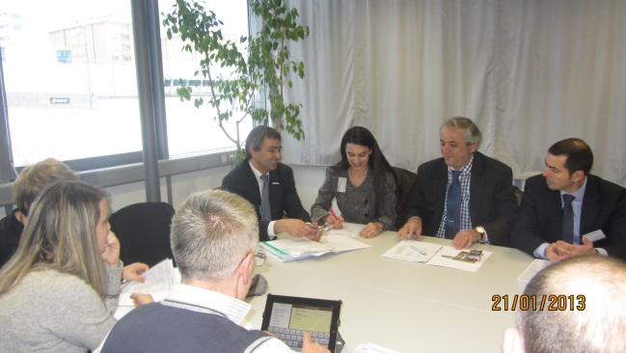 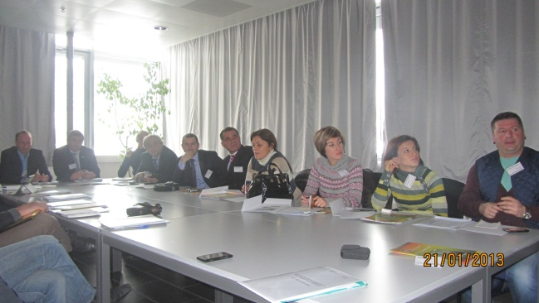

S. Nellen reminded that an incinerator should be sized for a ***minimum of 300’000 inhabitants*** to be efficient. The investment cost of the plant was 360 mio CHF. The authorization procedure for the construction lasted more than 15 years, because of the strong opposition from a part of the population to the project (as it occurs very often in the case of waste treatment facilities).

The plant ***produces energy (electricity and heat),*** which sales represents 25% of global costs***. The resting 75% are covered by the municipalities, who pay a tax for each ton of waste sent to the incinerato***r (around 200.- CHF/t, without transport).

S. Nellen reminded how important it is to ***pretreat the wastes*** in order to burn only the calorific ones. In Switzerland, this pretreatment is realized by the population itself (waste sorting).

After Mr. Nellen’s presentation, the delegation could visit the installations with a guide who explained more in details the technical aspects of the plant.

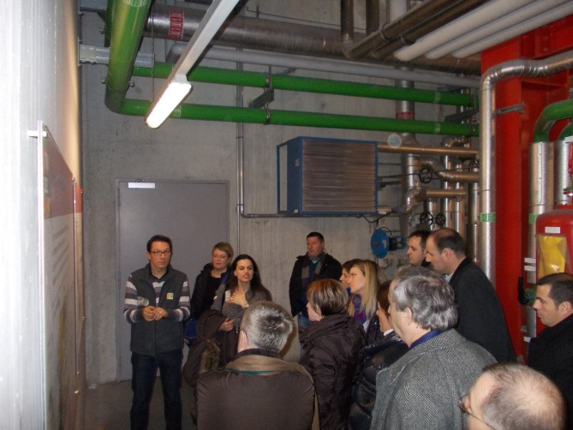 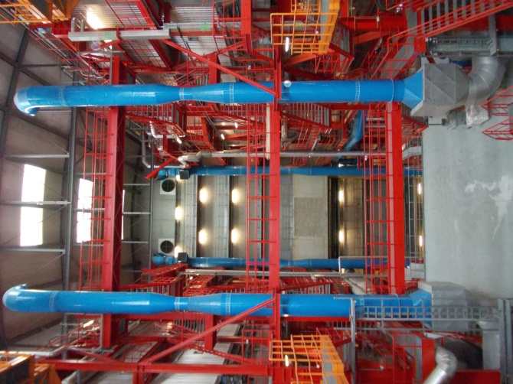

1. **Municipality of Pully**

In Pully, the delegation was welcomed by Laurent Balsiger, in charge of public works, and his deputy Sylvain Gorgevain, who presented the waste management in Pully, focused on the following topics: collection, LGU collaboration and taxes.

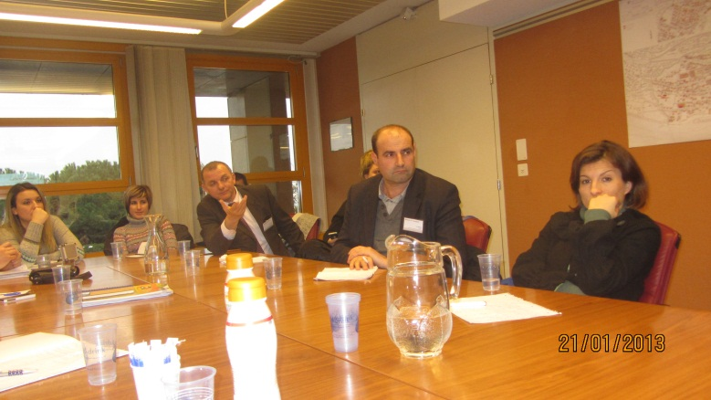

*Collection*

S. Gorgevain explained the organization of the collection, based on the ***volunteer contribution of the population to the ecopoints or to the waste sorting center, combined with door-to-door collection.*** The municipality contracted a service provider for 4 years, in charge of the collection and ***paid on the base of the weight of wastes collected***.

*Tax system*

S. Gorgevain focused on the tax system, made of one flat tax and one proportional tax.

* The flat rate is calculated according to the size of the building (m3). The bill is sent with the electricity bill, by the electricity furnisher.
* The proportional rate is paid through the “bag tax”, paid by the users when they buy waste bags (2 CHF per bag).

This system is specific to Pully, there are ***many different systems in other communes***.

A large discussion about this taxation system took place, concluding that such a system could not be replicable in Albania.

*LGU collaboration*

Pully collaborates with her neighbor Lausanne, with whom she shares one waste sorting place. This place is operated by Lausanne and Pully participates to the costs, proportionally to the number of Pully inhabitants using the waste sorting place. This involves an access control and frequentation statistics. ***The current inter-municipal solution is thus a win-win situation for both municipalities, in terms of effectiveness, efficiency and costs***.

After this presentation and discussion part, the delegation went on the field, visiting the waste sorting center and one of the “ecopoint” of Pully.

***Tuesday 22 January – “Working on a cost and tariff model for Albania”***

All the members of the delegation took part to this workshop day, the aim of which was the elaboration of a regional cost and tariff model for wastes as well as a national cost model in Albania. Different presentations on the theme were proposed by the participants.

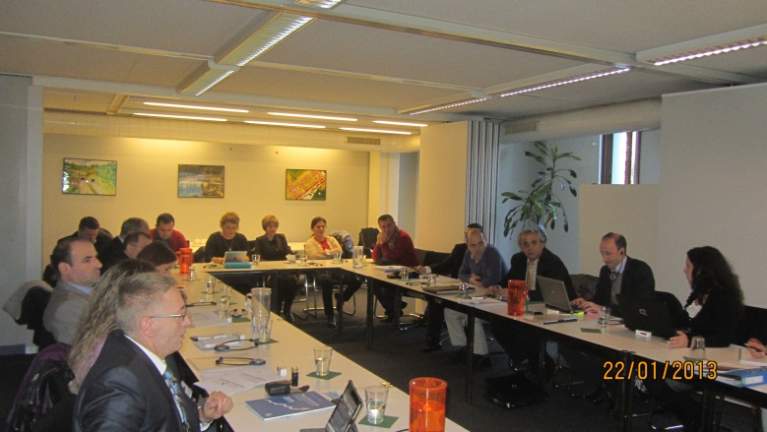

1. **Cost session**

*Water regulatory entity*

The water regulatory entity presented the tariffication model for water, based on five main objectives:

* Cost coverage (inc. amortization)
* Efficiency (show improval/progress)
* Affordability (water supply + sanitation tax <= 5% family income – international standard)
* Environmental efficiency (tariff should lead to an efficient use of water – limit water consumption)

The rate varies according to the category of consumer (family, public or private) and to the consumption (the tariff per cubic meter increases when the consumption is high).

The participants were interested in this model, which could (or at least certain key elements and principles) serve as an example for a tariffication on waste.

*Ministry of Environment*

The MoE reminded that laws and strategy on waste management were established and define different waste categories (end of life vehicles, batteries, electric and electronics, used oil, hazardous waste, biowaste,…). The main issue they are facing is fixing cost and tariff. Currently, the tariffs are insufficient and can’t cover the costs. This cost and tariff question is under the responsibility of LGU.

MoE agree that a regulatory entity would be very useful, and could be under the same umbrella as the water regulatory entity.

*Ministry of Transport*

MoT presented the national plan that foresees the construction of 12 landfills in the country, for a 150-200 mio euros budget, over 13 years of implementation. MoT specified three important points regarding the costs:

* Cost is heavily dependent on collection and transport efficiency (different from water sector)
* Regional landfill construction and future administration of landfills is a big challenge, which will influence costs and tariffing (example of Bushat shows that the finding of an accurate management is a challenge). Models of landfill operation and administration are missing, as well as a legislative framework.
* Regionalization is necessary, in order to increase efficiency and decrease the costs.

*Experience of cost and tariff in the LGUs*

G. Konalsj and E. Cani presented their feedback from their learnings in the LGUs where they were involved in the frame of the dldp programme in setting up and applying a cost and tariff model.

If the situation is different in each case, some problems are recurrent:

* Low income because of insufficient tax recollection rate, especially among families
* Need for an efficient tariff collection system
* No benchmark
* Need for a transfer station in order to reduce the transport costs
* Need for a methodology to calculate the costs and define the associated tariffs
* No reliable register (population)
* Operational costs could be reduced
* Collection system could be improved

*Cost model extended at the national level*

CSD reminded that the local cost model developed for Shkodra and Lezha assumed different hypothesis that need to be verified and further validated in order to extend this model nation-wide.

Cost is highly influenced by the frequency of waste collection, that could be reduced in most cases. The location of regional landfills is determinant as well, and still unknown, for most of them.

An open discussion took part after this presentation, broaching relevant points:

* Regional optimization and cost model (Shkodra/Lezha) is a good basis for a national cost model
* Compared to water, costs depend much more on logistical/management choice
* Basic model of the regional study is transferrable to other parts of Albania
* The model needs to be flexible in order to integrate local specificities and further innovations. It is important to keep in mind that the main uses of the model is to allow an LGU benchmarking and to show cost reduction opportunities (collection, implementation of transfer station, choice on the landfills’ location, etc). It is a tool, not a definitive result
* Importance of regional transfer stations and inter-LGU solutions

The model should be modified integrating the following notices:

* The model assumes two types of LGUs (urban and rural), which is not sufficient. It should consider other typical types, like coastal touristic LGUs (such as Velipoja, Shengjin) or remote mountains LGUs
* Salaries assumed should be verified (difference if public or private solutions)
* Awareness campaigns and tariff collection costs should be included in the cost calculation model

The major uncertain points are the following ones:

* Data accuracy (population and waste production) => the model can’t be better than the data and the data are often not fully reliable; one will need to work therefore with certain estimations
* Lack of knowledge about quantity of waste production (weighting in transfer stations needed) and stability of waste production in the time (seasonal differences etc)
* Further issues concerning the treatment
  + The position of the landfills is an essential parameter. A model would be necessary to identify the best sites, and maybe reduce the number of landfills.
  + The management and operation of landfills is not resolved yet
  + Many management/governance issues will influence their implementation in practice (Cooperation among different actors, inter-LGU cooperation)

=> A model could therefore also be an important element to help defining, what is optimal economically in terms of regional landfills

The following stakeholders should be involved for a national cost model elaboration: MoE, MPWT MoI, MoFinance, WRE, LGU associations, other donors/programmes/organisations (USAID, GiZ, URI etc), civil society, private sector

1. **Tariff session**

*Ministry of Finance*

Fran Brahimi from the MoF reminded the difference between tax and tariff in the Albanian legislation. A tariff is referred to the payment of a direct service and its collection should cover the cost of the service. The service should therefore be in principle cut from the beneficiaries who don’t pay for it. A good tariff should be transparent, equitable and give mutual benefit. PPP is allowed and promoted.

*Experience of Lezhe*

In Lezhe, businesses and institutions pay regularly the waste tariff, but only 10% of families pay for it, which involves that only 60% of costs are covered. The rate of the tariff is very low (1’500 lek/family/year) and could be paid by the families, even the low income ones. Different options were tested in order to increase the tariff recollection, but with few success until today.

*Definition of a tariff model*

CSD presented different possibilities on calculating a tariff. Different options can be chosen and will be determined by two main criteria:

* Data availability
* Political choices

The main choices that will have to be done are:

* Mode of calculation (per inhabitant, per property, per activity, per waste production,…)
* Who pays for the non collected tariffs?
* If and how to include in the tariff model social measures (households exemptions)?

*Revenue collection*

CSD made a brief presentation on the subject, proposing three main systems of revenue collection

1. direct door-to-door (with a higher risk of corruption);
2. a separate bill
3. a joint bill with water and electricity.

Whatever the choice, the main issue is to get an updated register of the clients (families, businesses and institutions).

The measures to increase revenue collection can be incentive (communication and awareness, invoicing reminders) or repressive (fines, “pillory”, cut water/electricity?).

After the presentations, the following relevant subjects were discussed:

* Need to identify main reasons for low tariff collection
  + Awareness of citizens?
  + Service quality?
  + Tariff too high/too low?
  + System of tariff collection?
  + Lack of reactions and sanctions?
* Importance of information to citizens, direct contact and pressure to them
* Sanctionary measures are important (example of Shkodra, where it was linked to civil registry)
* Role of revenue collection agency! – choice by LGU
* Lack of capacities of LGUs (need for database, software, balance sheets)
* Issue on taxation for local businesses should be looked at (Limit for business: Municipal taxes < 10% National taxes)

***Wednesday, 23 January 2013 – “Composting, recycling and landfills”***

The third day of the study tour was dedicated to a workshop in the morning, a visit of a landfill and composting center in the afternoon and a last visit to a neighborhood composting.

1. **Workshop**

In the morning, a limited group constituted of the Water Regulatory Entity, the Ministry of Environment, the Ministry of Transport, REC, CSD, dldp and Helvetas participated to the elaboration of an action plan on the cost and tariff model. A large part of the discussion focused on the problem of the location of the final landfills, which remains unknown for 40% of the territory and has a huge influence on the cost calculation.

As a conclusion, it was defined that the cost methodology would be extended to those 60% of the territory of Albania, where the future position of the landfill is known. The methodology will be based on the existing model and the manual from the water regulatory entity (REC and WRE will work together). On the remaining 40%, the model will be used as a tool to make recommendations on the landfill locations.

Regarding the tariff, CSD will propose different models, that will be tested in few LGUs by REC. Based on their feedback, the model will be modified, in order to deliver a local tariff methodology.

Collecting the required data will probably be an issue. Regarding this point, it was decided that:

* Civil register will be the official data regarding population, Ministry of Interior will be responsible for furnishing the data
* Ministry of tourism could be a source to give information regarding touristic frequentation of the LGUs
* Distances and roads will be given by Ministry of Transport

1. **Landfill and composting center visit**

After lunch, the delegation went by bus to Fribourg, in order to visit a landfill and a composting center. During the transportation, F. Schmidt explained the history of waste management in Switzerland, reminding that few decades ago, the situation was similar to Albania, with dumps in almost every village. It was a long way to get to the current situation where all municipal wastes are recycled or incinerated. Only the remaining wastes from the incineration and the wastes that can’t be recycled or incinerated because of their composition are disposed in sanitary landfills.

On the way, the bus stopped at the Sorval landfill, where F. Schmidt explained the history of this site monitored and managed by CSD for 30 years. Sorval is one of these old dumpsite. It had been restored and transformed in a sanitary landfill that is now closed and monitored. Despite its 2 mio. of cubic meters, it is now perfectly integrated in the landfill, the water going through is collected and treated and, as a matter of effect, the site doesn’t have anymore negative impact on the environment.

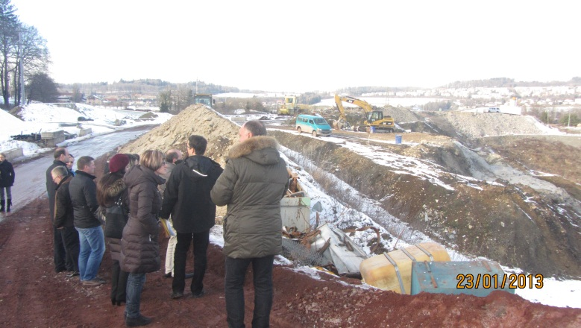

The Châtillon landfill is one of the landfills that are still operated in Switzerland. It is defined as a “bioactive landfill”, where polluted wastes are disposed. Sébastien Paratte, The CSD project manager involved in the follow up of the landfill, and previously involved in the Shkodra project, welcomed the delegation at the landfill. He exposed the organization and the technical issues.

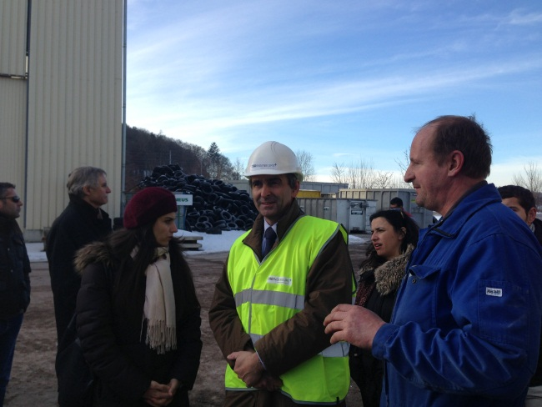 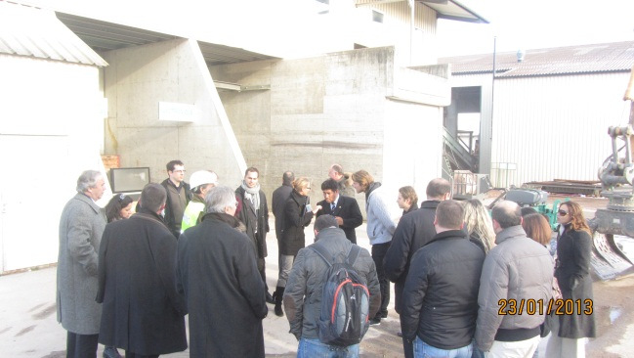

Then, the delegation could visit the waste sorting center, operated by a private company, specialized in the sorting of demolition and inert wastes.

On the same site, another company operates a composting center. The operator described each step of composting: reception of the material, grinding, swaths disposition and mechanic ventilation. He could also give some information about the economic model. They invoice 100.- CHF for each ton of biowaste received. The final product is sold 2 CHF/m3 (normal quality, treated 1 month) or 30 CHF/m3 (high quality, treated 3 months). In fact, the essential part of money recover comes from the treatment of waste, not on the selling of the product.

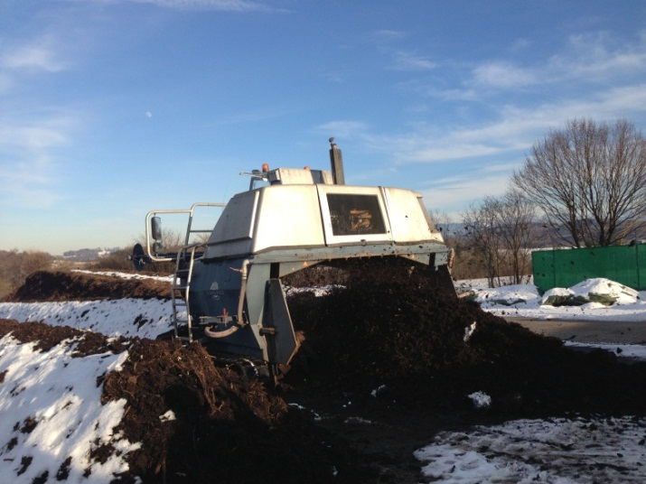

The discussions revealed that the issues of such a system in the Albanian context would be:

* The price of the treatment, that requires mechanization and energy (grinding and ventilation)
* The quality of waste, since the biowaste should be perfectly sorted and not contaminated with other wastes like plastics, to get a good final product

1. **Neighborhood composting**

In Fribourg, some neighborhoods have organized themselves in small associations, that operate composting at a small scale. Every inhabitant can bring there biowaste and each member of the association takes some time every week or two weeks to take care of the compost. Then, they can use the product, that is also sold on markets.

M. Kabitz, member of the association, explained the organization and the mutual benefit for the members and for the collectivity.

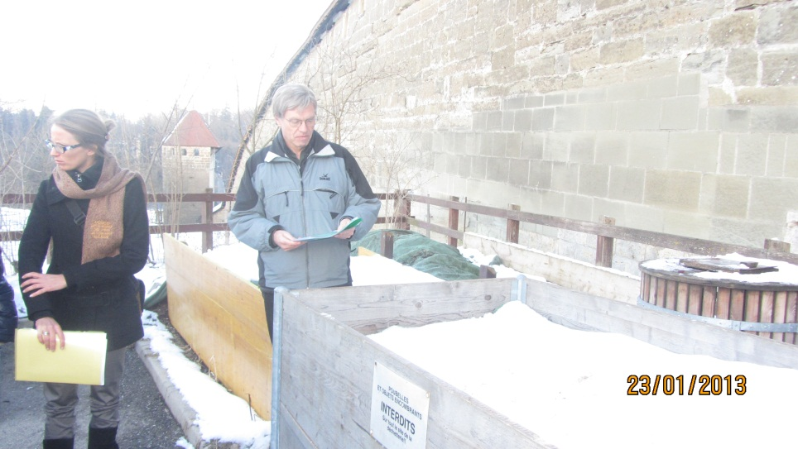

Official dinner on a boat over the Leman Sea, with the delegation members and the presence of Nathalie Barbancho (SDC).

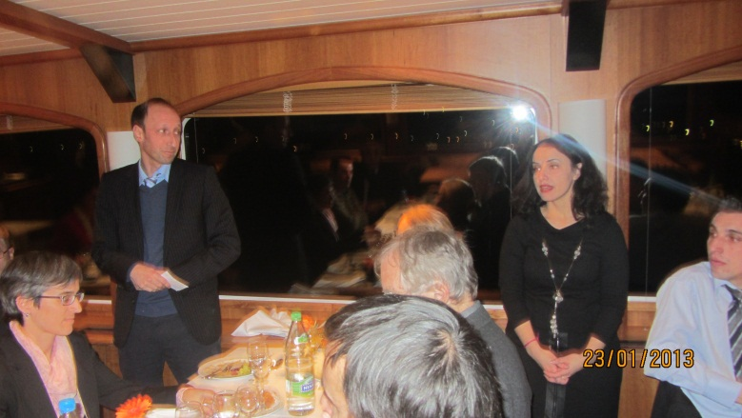

***Thursday 24 January 2013 – “Regional Transfer stations, municipal management and inter-municipal solutions”***

In Yverdon-les-Bains the director of STRID (Society for the Sorting, Recycling and Incinerating of the Waste), Mr. Jean Paul Schindelholz, welcomed the delegation and guided the visit on:

* the communal waste collection centre for the inhabitants of Yverdon-les-Bains ;
* the regional waste collection point of STRID ;
* the waste collection centre for companies.

In their premises, he presented the status and activities of STRID. It is one of the 8 waste management areas of the Canton of Vaud. STRID is a limited company whom shareholders are mainly the communes of the management area and some private companies.

1. **Communal waste collection centre (déchèterie d’Yverdon-les-Bains)**

Some figures: modern collection centre built in 2011. In 2012, 64’338 passages (2200 t/y), i.e. 220 passages per day (~34kg/day). Each passage costs about 6 CHF / inhabitant as operation cost.

STRID also rents a premise to an association. This is a place, called “Recyclerie”, where people can bring objects to be repaired and sold by the association. It is a social place where people can meet and discuss.

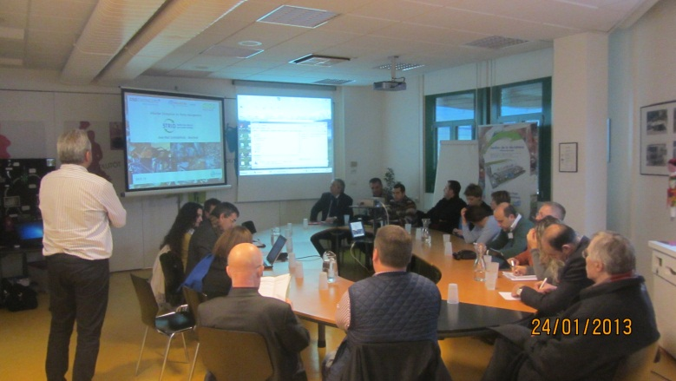

1. **Regional waste collection point**

STRID recollects and concentrates recycled waste from communal installations. In this sector, STRID is competing with the private sector but there is a common practice (STRID 🡪 communes and Private companies 🡪 industries). Due to the large volumes treated, STRID can propose competitive prices.

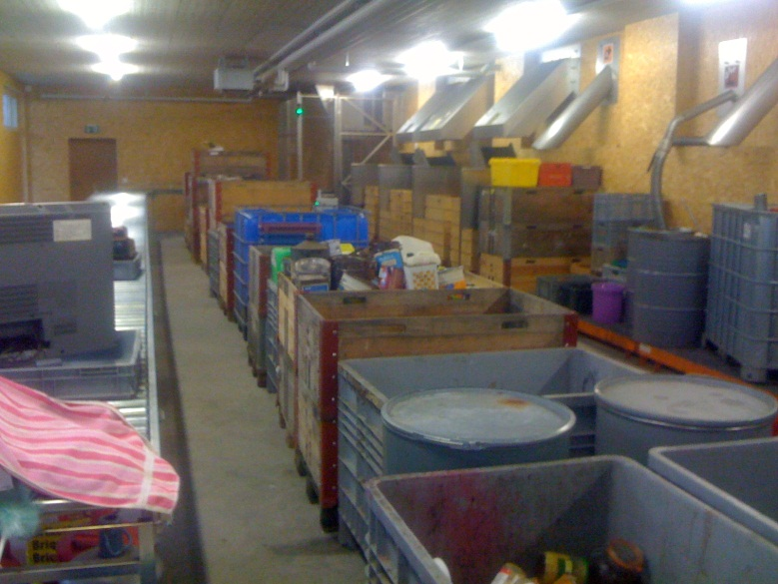

1. **Waste collection centre for companies**

This place is destined to the collection of the waste of private companies. It is equipped with a system of weighting.

For household waste and large size waste, they are crushed and then loaded into a 90m3 trailer without compaction (total weight of waste 16-18t). This simple model could be convenient and easily applied for the Transfer Station in Skhodra.

**Important messages:**

* If good sorting is wanted, good installations, good training and communication are needed ;
* Rationalization of the cost of transport by using a regional collection and transfer station ;
* Rationalization of the routes and tours collection ;
* Rationalization of the waste collection and professionalization (6 days a week instead of some hours per day per week) ;
* Waste recycling doesn’t generate money, it only reduces costs of treatment becoming less expensive than incineration ;
* Federal authority doesn’t fix price of taxes in Switzerland (as opposed to Albania) but defines means to collect them ;
* There is a need of benchmarking between LGUs.

Mr. Olivier Mani from COSEDEC (Cooperative for public awareness on waste management) presented this non-profit organization which is very active in Switzerland (2’200 animations) during events, at schools, etc. Its goal is to inform, train and sensitize. Sensitization should start with children that they can train their parents.

Before lunch in Café du Château, the delegation was received in the City Hall and was offered an aperitif by Mr Von Siebenthal, mayor of Yverdon-les-Bains. Shkodra and Yverdon-les-Bains entertain close relations since years.

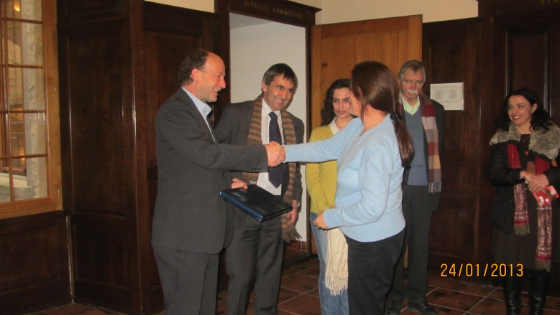

The afternoon was dedicated to discussions on the different programs of Shkodra and Lezha, with the vice-mayors of each city and the private companies of waste management.

1. **Program of Shkodra**

Discussions were held on the situation with the current waste collection contract (achievements and difficulties). There is a need to define a list of data to be collected for the preparation of tender, then collect them and carry out a mission to verify these data.

The waste company contract ends at 8th July 2013. For procurement reasons and timetable, deadline for tenders is fixed at 25th April 2013.

Questions on the transfer station are still open (inclusion in the tenders, model of operation and contracting, type of transfer station (sorting site, recycling site,…).

1. **Program of Lezha**

Discussions were held on means to increase revenue, provide information, organize tax collection and define sanctions for those who don’t pay the waste taxes.

***Friday 25 January – “Harvesting the results and preparing the work plan”***

Internal meeting to discuss main results and plan next steps in the frame of the dldp waste management support package (work plan, see draft in the annex).

1. **Conclusion and Lessons Learned from the Project’s perspective**

General conclusions and learnings

* The main objectives of the study visit could be achieved. The combination of exposure and internal workshop allowed a direct transfer of learnings into the practice for Albania, which was crucial to define the final work plan for dldp.
* The study tour organisation was excellent; in spite of the dense programme, the delegation was highly motivated and attentive. The good connections from CSD to the different organisations visited, as well as an accompaniment and moderation of CSD/HSI/dldp allowed focused discussions.
* The internal workshop sessions were well prepared (by the organizers and the delegation members), especially inputs from delegations members (e.g. RWE, ministries) raised the quality and the ownership.
* The group composition was good, main actors (focus on high level technical level) of Albania were present. A particular success was the participation of 4 different ministries and the director of the WRE, which proved to be helpful to address also potential national/political challenges.
* Commitment and interest of the participants were high, which should contribute to further increase ownership of the activities carried out in the frame of dldp.
* The project and the participants could benefit a lot from the experience of the water regulatory entity (cost and tariff calculation and moderation + need of a regulatory entity in the waste context).

Issues to consider in the dldp programme

* Incineration remains an expensive solution, not yet affordable for Albania. Still it should be the long term vision for the country
* Landfills and transfer station location remains a big issue. The model developed in the project could be a tool to determine the best locations and show the possibilities of cost reduction by InterLGU cooperation for transport and landfilling.
* The cost model will be modified in order to integrate more parameters like tourism/coastal areas, remoteness/mountain areas.
* Revenue collection remains a big issue that can only be solved by a strong invoicing system, reminders, incentive and repressive measures.
* Composting at a large scale is expensive. A local organization and local solutions are more adequate for the Albanian context, and would be more replicable.

|  |  |
| --- | --- |
|  | *Annexes:*  *Annex 1: List of Participants*  *Annex 2: Detailed Programme*  *Annex 3: Draft Work plan* |

*Annex* ***3****: Work plan 2013* ***(based on internal workshops)***

|  |  |  |  |  |
| --- | --- | --- | --- | --- |
| **1 Elaboration of national cost model** | | | | |
| **The main goal is to elaborating, based on the dldp study presented during the conference in March-April a cost model, which can be applied nation-wide** | | | | |
| **What/milestones** | **Date** | **Who** | **Product** | **Comment** |
| Collection of additional data for national cost calculation | 20 Feb | dldp, ministries | Data for national cost calculation | Based on list of required data developed by CSD |
| Further study and validation of water regulatory entity model | 20 Feb | CSD/REC |  |  |
| Reflection of changes into the manual | Feb-March | IT/REC |  |  |
| Integrate changes into training module | 31 March | Dldp/REC/CSD | Training modules |  |
| *Training on adjusted national cost calculation model* | April | dldp/REC | Training conducted |  |
| *Calculation of costs at national level* | March-20 June | REC |  | For estimated 60% of the territory, where the landfill location is clarified |
| *Develop recommendations for optimizing the model* | June/July | REC/dldp |  |  |
| *Finalize national cost model* | Aug/September | Dldp/REC/CSD | National cost model covering 60% of territory |  |
| *Disseminate learnings and products at the national conference* | Nov | Dldp/REC/CSD | National conference |  |

|  |  |  |  |  |
| --- | --- | --- | --- | --- |
| **2 Elaboration of regional cost and tariff model** | | | | |
| **The main goal is to elaborate, based on the dldp study on a regional cost model presented during the conference, a cost and tariff model at the regional level (Shkodra/Lezha region)** | | | | |
| **What/milestones** | **Date** | **Who** | **Product** | **Comment** |
| Develop 2-3 tariff models as options for discussion | 15 Feb | CSD | 2-3 tariff models |  |
| Study and validation of models (based on Albanian realities) | 28 Feb | REC/dldp |  |  |
| *Piloting of the selected tariff model in 2-3 representative LGUs* | March-June | REC/dldp, 2-3 partner LGUs |  |  |
| Finalize regional cost and tariff model | July-Sept | Dldp/REC/CSD | Regional cost and tariff model |  |
| Ongoing support to Ministry in regarding tariffs at national level | Sept-Oct |  |  |  |
| *Disseminate learnings and products at the national conference* | Nov |  | National conference |  |

|  |  |  |  |  |
| --- | --- | --- | --- | --- |
| **3 Inter-LGU cooperation** | | | | |
| **There are still only few expamples of functioning inter-LGU cooperation practices in Albania. Particularly in the frame of the new national waste management strategy and plan, regtional and inter-LGU solutions must be further promoted and tested.**  **The main goal is**   1. **to conduct – based on dldp and other experiences – an in depth analysis of interLGU cooperation models, options, experiences, potentials and challenges accountered** 2. **based on the analysis, to select in consultation with dldp a model for inter-LGU cooperation to be supported in the frame of dldp in the future** | | | | |
| **What/milestones** | **Date** | **Who** | **Product** | **Comment** |
| Workshop and finalization of TOR | 18-22 Feb | Dldp, partners | Final TOR | Invited are pre-identified inter LGU cooperation |
| Proposal of SP, Contracting of SP | 15 March | Dldp, SP | Contract with SP |  |
| Rapid assessment of the opportunities for InterLGU cooperation | March/April | SP, partner LGUs |  | Assess pre-identified potential models for inter-LGU cooperation |
| Information and awareness raising on the benefits for interLGU solutions among pre-identified LGUs | April | SP, partner LGUs |  |  |
| Select model to be supported | May | SP, dldp |  | Based on evidenced commitment of partners and road map for realization |
| Development of Project Proposal for interLGU cooperation for waste optimization to be implemented in 2014-2015 | 15 Oct | SP dldp, partner LGUs | Finalized project proposal | Must be in line with EU standards for project proposals |

|  |  |  |  |  |
| --- | --- | --- | --- | --- |
| **4 Citizens information campaign to raise awareness and tariff payment rate** | | | | |
| **One of the main pitfalls identified for sustainable and affordable waste management schemes in LGUs is the low payment rate (particularly from households). Dldp will thus support in the Lezha municipality and the Velipoja commune in a public awareness campaign and the introduction of enforcement measures to address this problem. Learnings from the Lezha model should than serve for other LGUs as good practice** | | | | |
|  | **Date** | **Who** | **Product** | **Comment** |
| Finalization of existing support package in Lezha | 15 Feb | URI/dldp | Final report |  |
| Assessment, elaboration of TOR and activity plan | 30 March | Dldp, EDEN, partner LGUs | Agreed support package and SP contract |  |
| Implementation of support | April-Oct | Dldp, EDEN, partner LGUs | Good practice) | Raise of payment rate, information campaign, sanctioning system |

|  |  |  |  |  |
| --- | --- | --- | --- | --- |
| **5 Support to Shkodra municipality in preparing the new tender and assessing options for financial optimization** | | | | |
| **Dldp will support the Shkodra municipality in the preparation of the new tender for the waste service. Of particular importance are technical specifications, the financial part (cost and tariffs), information to citizens, introduce the option of a transfer station** | | | | |
|  | **Date** | **Who** | **Product** | **Comment** |
| Support LGU in technical specification for the new tender and contract | Feb-24 April | Dldp, CSD, municipality | Final tender documents |  |
| Assess and discuss scenarios for financial optimization | March-May | Dldp, CSD, municipality |  |  |

|  |  |  |  |  |
| --- | --- | --- | --- | --- |
| **6 Support to Shkodra municipality in preparing the feasibility and business plan and the implementation of a transfer station** | | | | |
| **Dldp will support the Shkodra municipality in a feasisibility assessment and the business plan for a transfer station. Transfer stations are crucial elements for future regional solutions and affordable waste services, with inter-LGU set ups, in line with the national WM strategy and plan** | | | | |
|  | **Date** | **Who** | **Product** | **Comment** |
| Identify necessary legal permits etc | 28 Feb | Dldp, municipality, Ministries |  |  |
| Assess model(s) for organization and administration of future TS | March-May | CSD, dldp, municipality |  |  |
| Elaboration and approval of business plan | Feb-April | CSD, dldp, municipality | Business plan |  |
| Technical specification of the construction and equipment (tender preparation) | April-Oct | CSD, dldp, municipality | Tender documents with technical specifications |  |
| Procurement and construction | Nov- | municipality |  | Co-financing of dldp is planned |

|  |  |
| --- | --- |
| **Milestones** |  |
| April | Tender Shk municipality |
| April | ToT on national cost model |
| April-Jun | Dissemination of regional cost and tariff model |
| April-Nov | 6 Workshops wither inter-LGU expert group |
| November | Dldp National WM conference |
| November | Procurement of transfer station in Shkodra municipality |

dldp/Feb 2013

1. See Annex 1 for a detailed list of participants
2. See Annex 2 for the program of the week